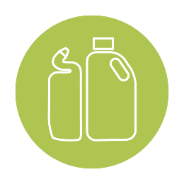
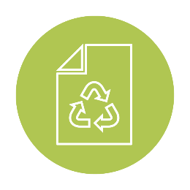
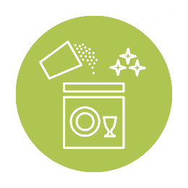

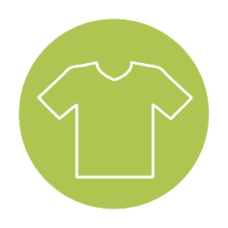
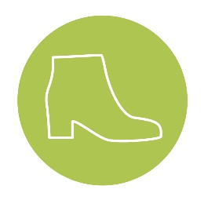
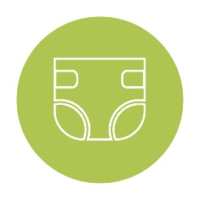
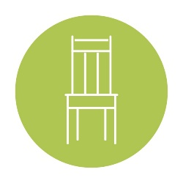
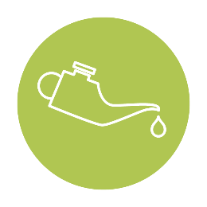
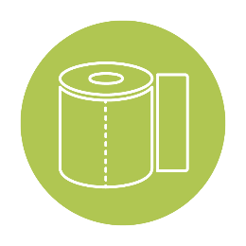
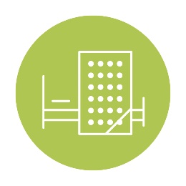

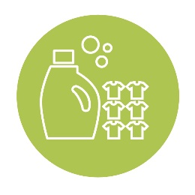

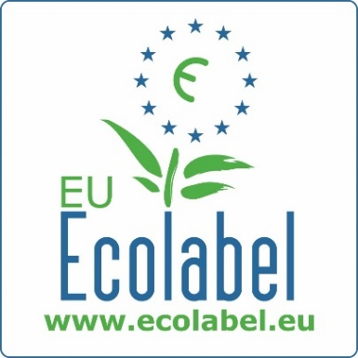
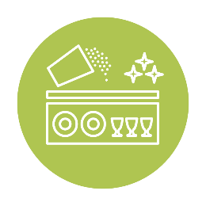

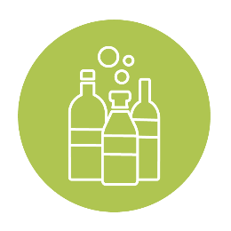
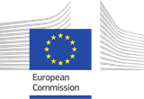
Lubricants

EU Ecolabel
DIGITAL TOOLKIT

Funded by

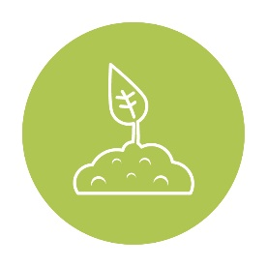

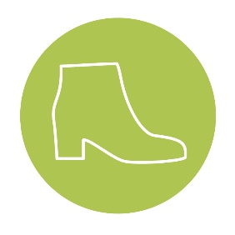
October 2020

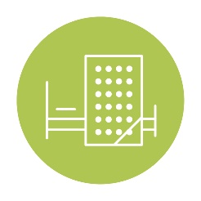

Digital toolkit – Lubricants – October 2020

Dear all,
Welcome to the October 2020 Digital toolkit. In this toolkit, you will find product-group specific communication content for Lubricants. Please find below instructions on how to best use this content:

WHY use this toolkit?
This content has been developed to provide you with ready-to-use material to facilitate communication on your own social media or website pages in order to collectively optimise outreach to our B2B and B2C target audiences. The Helpdesk posts all of the content listed within each toolkit on the official EU Ecolabel and EU Environment social media and website pages, however in order to have increased visibility of this content, we encourage you to publish this same material on your national social media and website pages, and share it with your partners and multipliers (such as NGOs, journalists or sustainability and lifestyle bloggers, etc).

HOW to use this toolkit?
This material can be used as-is (copy/paste), however depending on your country it may have the most impact if the content is translated into your national language and/or edited for your target audience. Make sure to refer to the hashtag #EUEcolabel, and follow and tag the EU Ecolabel LinkedIn account (@EU Ecolabel), the EU Environment Twitter (@EU_ENV) and Instagram (@ourplanet_EU) accounts, when publishing on social media, so that we share your posts on our page.

WHAT material is in this toolkit?
The following content is available within this toolkit for you to disseminate:
- Ambassador Success Stories
- Social media posts for Twitter, Facebook, and LinkedIn
- Relevant hashtags and social media accounts to use and tag within the post
- Product-group specific articles
- Product group factsheet

Feel free to send the Helpdesk feedback and suggestions concerning the toolkits—your comments will help improve their content.

Best wishes,
The EU Ecolabel Helpdesk Team

Content
I. Success stories: EU Ecolabel Ambassadors 4
II. Social media posts 5
III. Social media tags, links and influencers 10
IV. Article - EU Ecolabel lubricants help preserve aquatic environments and biodiversity 11
V. Factsheet on lubricants 12

Success stories: EU Ecolabel Ambassadors

Axel Christiernsson AB, Sweden | Verkol S.A.U, Spain
Several hazardous substances present in conventional lubricants can leak in wastewaters, and negatively affect the environment.  "The EU Ecolabel aligns with our main sustainability goals. Our policy consists in manufacturing resource efficient products, with a higher level of biodegradability.”  Mikael Kruse, Axel Christiernsson AB’s Group Product Manager  The Swedish manufacturer of lubricants was awarded with the EU Ecolabel in 2016 and is committed to continuously reducing the environmental impact of its products. A thorough analysis of their components and additives’ impact on natural resources determines whether they can be used in products, optimising the durability and sustainability of lubricants sold. | The design of conventional lubricants can create large amounts of waste sent to landfills.  The Spanish company Verkol S.A.U. a Quaker Houghton Company, manufactures several lubricants that have been awarded with the EU Ecolabel since 2017. Verkol S.A.U. seeks to minimize the impact of their products on human beings, animals and the environment, and is concerned with the entire product life cycle, which are also included in EU Ecolabel criteria. In fact, Verkol S.A.U. is a pioneer in sustainable lubricants, demonstrated by its compliance with the prestigious quality management standard, ISO 9001, the environmental management standard, ISO 14001, and the highly demanding automotive quality management standard,  IATF 16949. The company has actually worked under a quality and environmental management system since the 1990s.
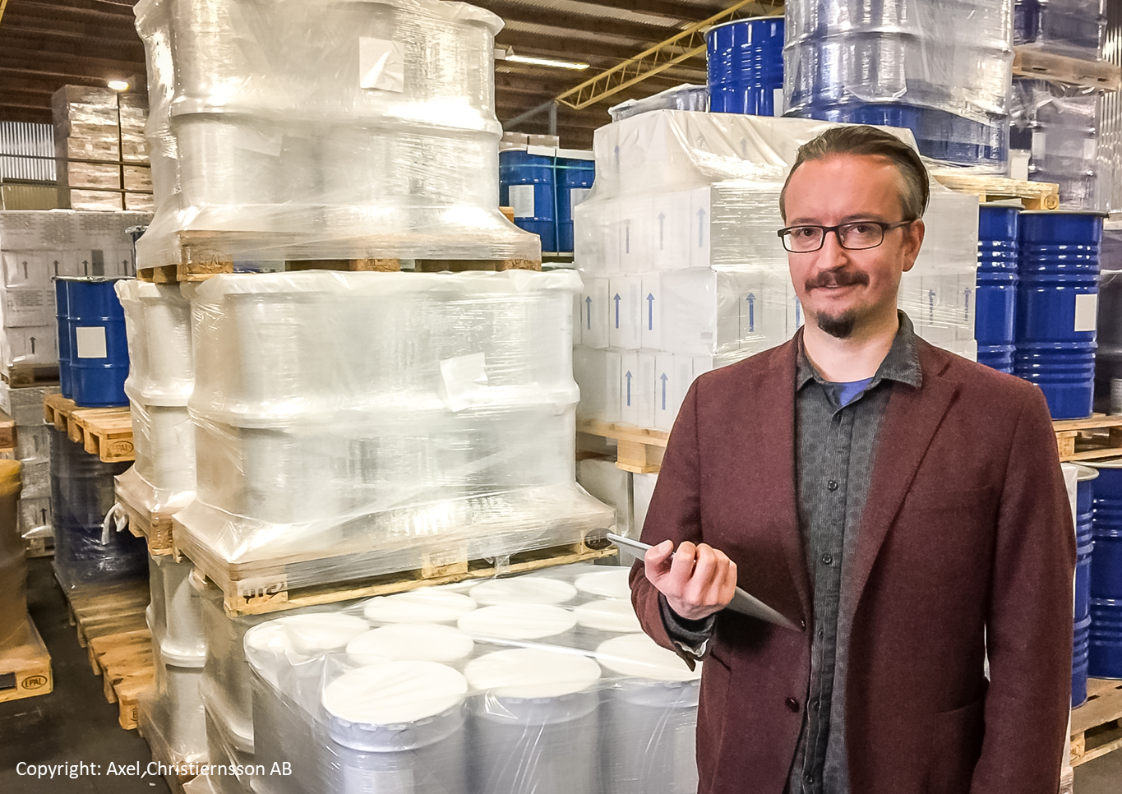 | 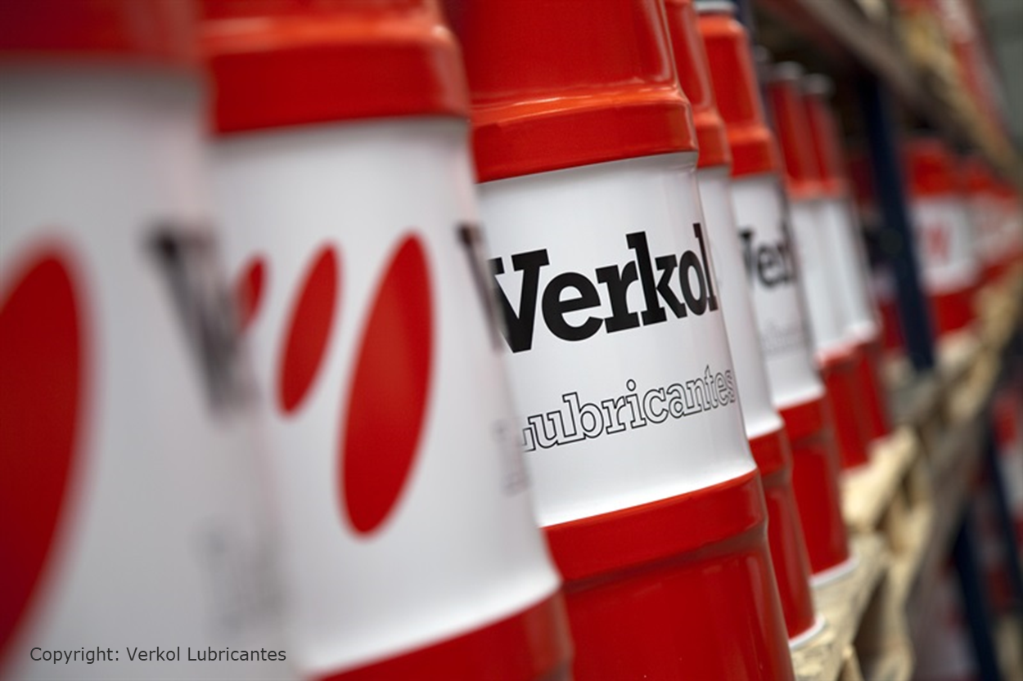

Social media posts

- Type of post & tags | Facebook / LinkedIn | Twitter | Visual
LH focus:  Axel Christiernsson AB  Tags:  #CircularEconomy  #EUGreenDeal  #BuildBackBetter | "The #EUEcolabel aligns with our main sustainability goals. Our policy consists in manufacturing resource efficient products, with a higher level of biodegradability.” Mikael Kruse, @Axel Christiernsson AB’s Group Product Manager  The Swedish manufacturer of lubricants was awarded with the EU Ecolabel in 2016 and is committed to continuously reducing the environmental impact of its products. A thorough analysis of their components and additives’ impact on natural resources determines whether they can be used in products, optimising the durability and sustainability of lubricants sold. | "The #EUEcolabel aligns with our main #sustainability goals. Our policy consists in manufacturing resource efficient products, with a higher level of #biodegradability for our #lubricants” Mikael Kruse, @Axel Christiernsson AB’s Group Product Manager
LH focus:  Verkol S.A.U  Tags:  #CircularEconomy  #EUGreenDeal  #BuildBackBetter | The Spanish company Verkol S.A.U. a Quaker Houghton Company, manufactures several lubricants that have been awarded with the #EUEcolabel since 2017. Verkol S.A.U. seeks to minimize the impact of their products on human beings, animals and the environment, and is concerned with the entire product life cycle, which are also included in EU Ecolabel criteria. In fact, Verkol S.A.U. is a pioneer in sustainable lubricants, demonstrated by its compliance with the prestigious quality management standard, ISO 9001, the environmental management standard, ISO 14001, and the highly demanding automotive quality management standard,  IATF 16949. The company has actually worked under a quality and environmental management system since the 1990s. | The Spanish manufacturer ‘Verkol Lubricantes’, awarded with the #EUEcolabel, looks into the entire product life cycle of their #lubricants. They have been working under a Quality & Environmental Management System, and comply with the prestigious #ISO9001 and #ISO14001 standards.
General news  March 2020 statistics  Tags:  #CircularEconomy  #EUGreenDeal  #BuildBackBetter | #Didyouknow? Consumers can access over 70 000 #EUEcolabel products across Europe!  In fact, Paints & Varnishes as well as Hard Surface Cleaning Products have grown significantly since September 2019.  EU Ecolabel statistics have just been published on our website if you want to learn more --> https://ec.europa.eu/environment/ecolabel/facts-and-figures.html | #Didyouknow? Consumers can access over 70 000 #EUEcolabel products across Europe!  Learn more about our statistics --> https://ec.europa.eu/environment/ecolabel/facts-and-figures.html | 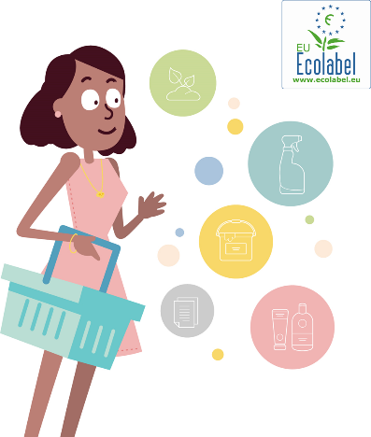
Current issue focus:  Overuse of lubricants  Tags:  #CircularEconomy  #EUGreenDeal  #BuildBackBetter #ZeroWaste | To limit unnecessary oil leaks, #EUEcolabel lubricants’ packaging are eco-designed to avoid spillage thanks to narrower container openings. A warning message on the packaging is also particularlyhelpful in guiding consumers on how to properly #dispose lubricants.  More about our lubricants --> http://ec.europa.eu/ecat/ | To limit unnecessary oil leaks, #EUEcolabel lubricants’ packaging are eco-designed to avoid spillage thanks to narrower container openings. A warning message on the packaging is also particularly helpful in guiding consumers on how to properly #dispose lubricants. | 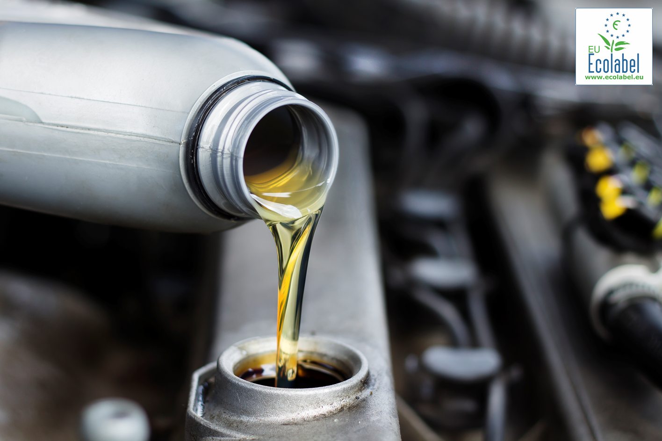
Current issue focus:  Hazardous substances  Tags:  #CircularEconomy  #EUGreenDeal  #BuildBackBetter #ToxicFree | Since most lubricants are liquid-based, they easily end up in soils, #water, rivers and lakes. To protect the aquatic environment, #EUEcolabel criteria for lubricants set ambitious restrictions on hazardous substances, in direct and indirect contact with any living organisms!  More about our lubricants--> http://ec.europa.eu/ecat/ | Since most lubricants are liquid-based, they easily end up in soils, #water, rivers and lakes. To protect the aquatic environment, #EUEcolabel criteria for lubricants set ambitious restrictions on hazardous substances, in direct and indirect contact with any living organisms! | 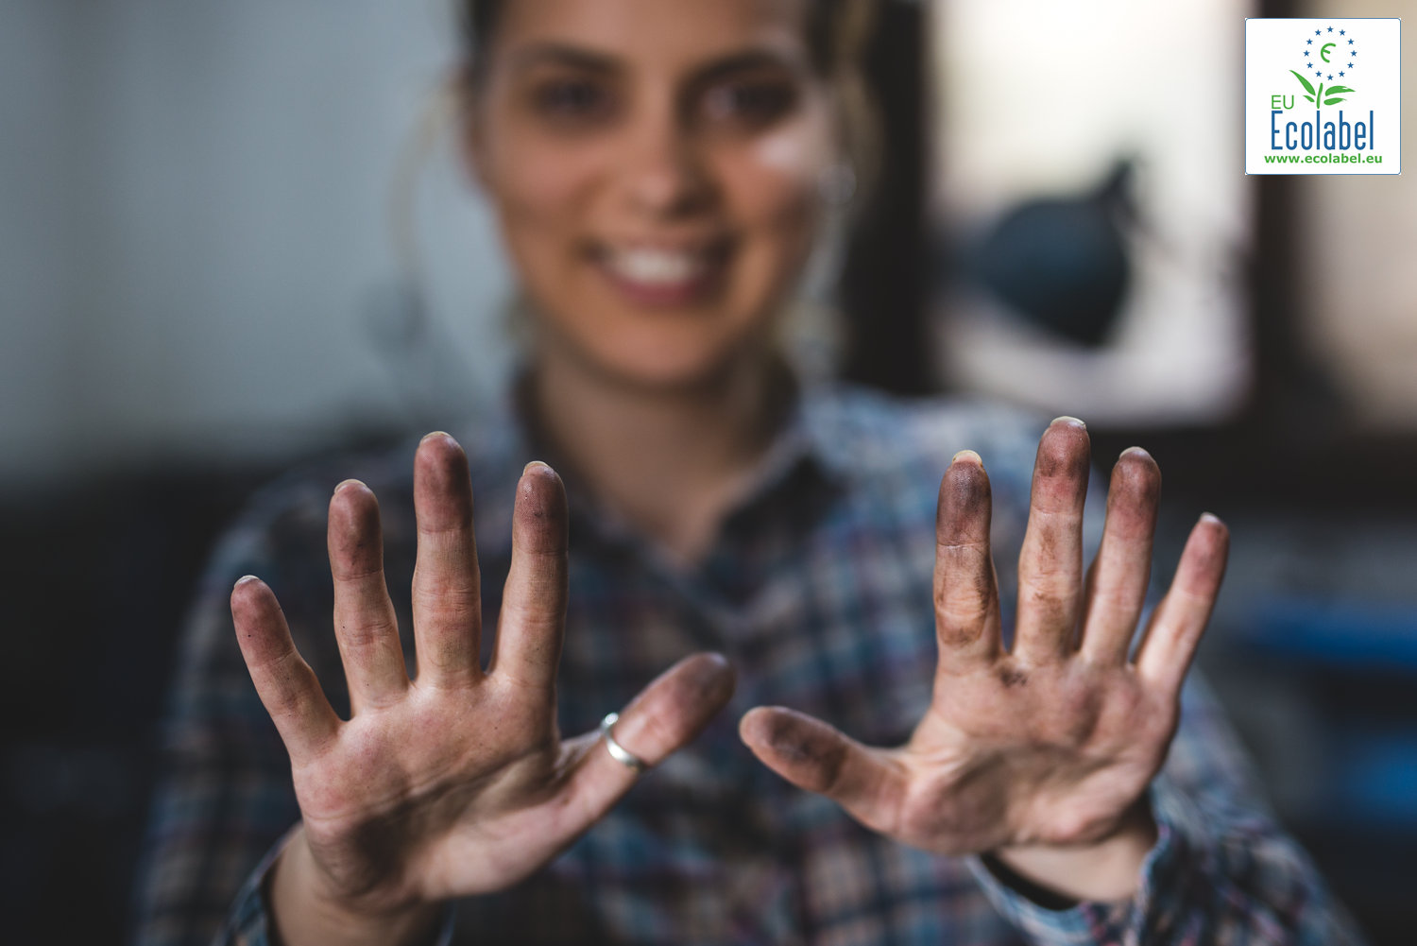
Current issue focus:  Deforestation  Tags:  #CircularEconomy  #EUGreenDeal  #BuildBackBetter | To tackle #deforestation from unsustainable palm oil plantations, #EUEcolabel lubricants containing palm oil must make sure it complies with sustainable production certifications such as the #RSPO.  More about our lubricants--> http://ec.europa.eu/ecat/ | To tackle #deforestation from unsustainable palm oil plantations, #EUEcolabel lubricants containing palm oil must make sure it complies with sustainable production certifications such as the #RSPO. | 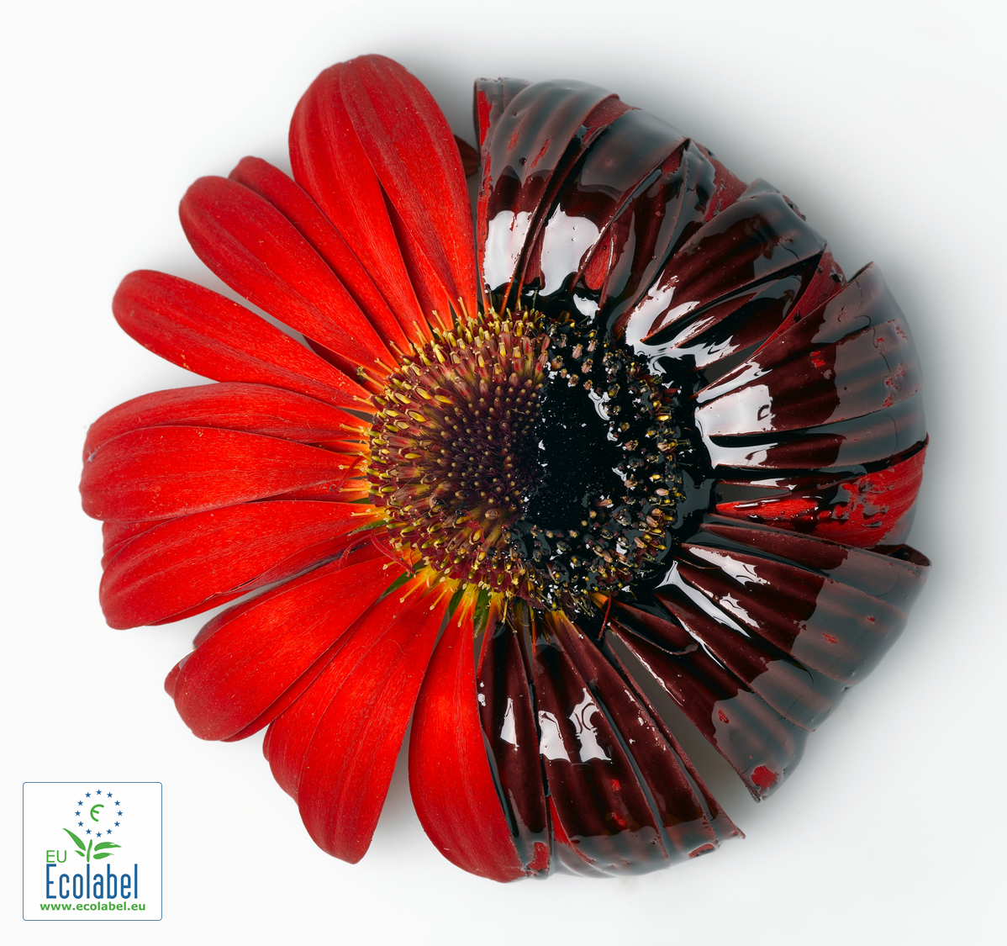
Current issue focus:  Recycled plastic  Tags:  #CircularEconomy  #EUGreenDeal  #BuildBackBetter | #DidYouKnow? The #EUEcolabel supports the EU Circular Economy Action Plan by imposing a minimum of 25% of recycled #plastic within the composition of certified lubricants #plastic packaging!  More about our lubricants--> http://ec.europa.eu/ecat/ | #DidYouKnow? The #EUEcolabel supports the EU Ciruclar Enconomy Action Plan by imposing a minimum of 25% of recycled #plastic within the composition of certified lubricant #plastic packaging! | 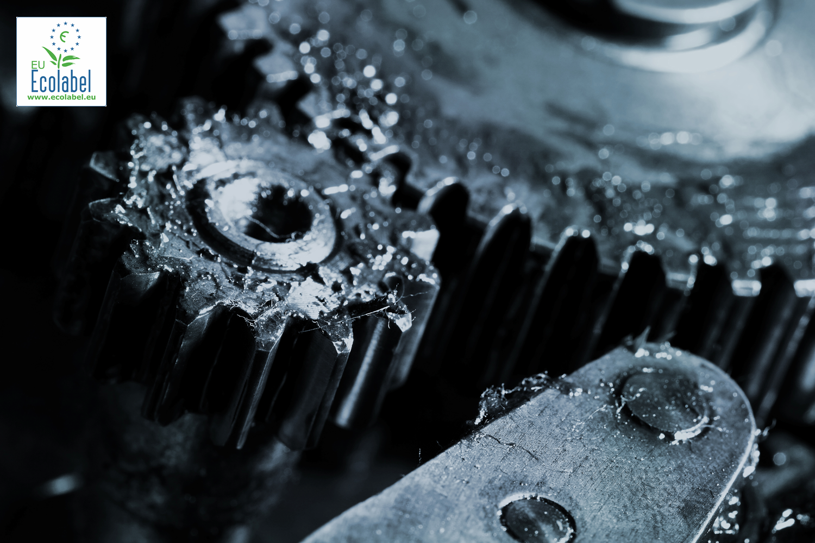
Current issue focus:  Biodegradability of lubricant  Tags:  #CircularEconomy  #EUGreenDeal  #BuildBackBetter | #DidYouKnow? To protect biodiversity, #EUEcolabel lubricants have an increased #biodegradability level and reduced number of toxic substances and ingredients present in the product  More about our lubricants --> http://ec.europa.eu/ecat/ | #DidYouKnow? To protect biodiversity, #EUEcolabel lubricants have an increased #biodegradability level and reduced number of toxic substances and ingredients present in the product | 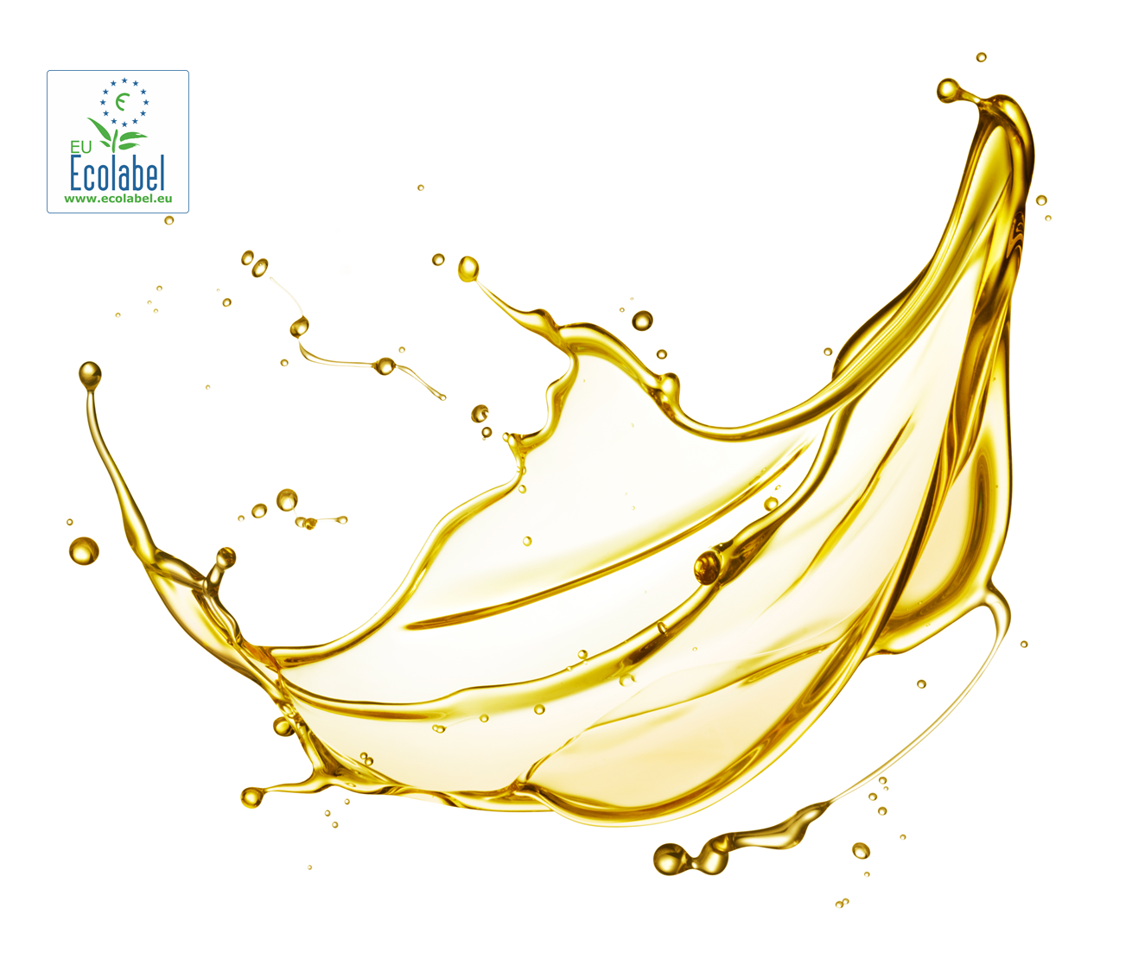

Social media tags, links and influencers

Feel free to use the following hashtags (#EUEcolabel, #CircularEconomy) and accounts in your social media posts in order to increase visibility of your posts.
Facebook influencers | @EUEnvironment ; @ZeroWasteFrance ; @EuropeanEnvironmentalBureau ; @AFNOR; @Axel Christiernsson International AB
Twitter influencers | @EU_ENV ; @bmoralesbailon (Blanca Morales); @Green_Europe (EEB) ; @beuc (BEUC) ; @AFNOR ; @ademe ; @ZeroWasteFR ;
Linkedin  Influencers | @EU Ecolabel ; @European Environmental Bureau; @BEUC; @Axel Christiernsson International AB

Article - EU Ecolabel lubricants help preserve aquatic environments and biodiversity
EU Ecolabel lubricants help preserve aquatic environments and biodiversity
It is estimated that 12 million tons of lubricants are released into the environment worldwide. Mechanical lubricants are oil-based substances that are crucial to increasing the lifespan of engines and machinery by reducing friction amongst parts. However, conventional lubricants present a threat to biodiversity and particularly aquatic environments when released as water waste, often during manufacturing, due to their toxicity level. EU Ecolabel criteria for lubricants impose restrictions on the hazardous substances used in product formulas, to ensure a safer product disposal.

As most lubricants are liquid-based, they can easily end up in soil, rivers and lakes as substances accidently leak from the factory during manufacturing. Unfortunately, most conventional lubricants contain harmful chemicals in their formula that can endanger aquatic fauna and flora. EU Ecolabel criteria for lubricants tackle this issue by setting ambitious restrictions on toxic ingredients. Furthermore, to tackle deforestation from unsustainable palm oil plantations, EU Ecolabel lubricants containing palm oil must make sure it complies with sustainable production certifications such as the RSPO (Roundtable for Sustainable Palm Oil).

EU Ecolabel lubricants are also highly biodegradable in water and present low bioaccumulation potential, which reduces the possibility of organic organisms becoming exposed to toxic chemicals when these lubricants inadvertently seep into aquatic environments. To protect the aquatic life, the product toxicity is assessed on flora and fauna, and more specifically on fish, crustacean and aquatic plants. The EU Ecolabel can be an efficient tool to stimulate a more sustainable production of lubricants in Europe and promote circular economy. EU Ecolabel criteria are aligned with the EU Waste Framework Directive, which lays down waste management principles for making the EU a circular society.

Sources :
https://eur-lex.europa.eu/legal-content/EN/TXT/?qid=1542112371100&uri=CELEX:32018D1702
https://www.lelubricants.com/wp-content/uploads/Green-Lubricants-white-paper.pdf
https://www3.epa.gov/npdes/pubs/vgp_environmentally_acceptable_lubricants.pdf
https://ec.europa.eu/environment/waste/oil_index.htm

Factsheet on lubricants

EU Ecolabel lubricants are eco-friendly alternatives to conventional lubricants, aiming to decrease the negative impact of these products on our biodiversity, through respecting a wide scope of environmental criteria. The EU Ecolabel takes a holistic approach for its criteria, whose regulations are determined according to ‘Life Cycle Analyses’. The aim of those criteria should be to promote products that have a limited impact on the aquatic environment, contain a limited amount of hazardous substances and performance as well as or better than a conventional lubricant available on the market. In line with the objectives of the European strategy for plastics in a circular economy), the criteria should also seek to facilitate the transition to a more circular economy by encouraging improved design and by further incentivising the demand for recycled materials.
‘Lubricants’ are understood within the criteria, to be products capable of reducing friction, adhesion, heat, wear or corrosion when applied to a surface or introduced between two surfaces in relative motion, or is capable of transmitting mechanical power. The scope of this product group encapsulates any lubricant that falls under the following three sub-categories: (a) the Total Loss Lubricants (TLL) sub-group, which shall comprise chainsaw oils, wire rope lubricants, concrete release agents, total loss greases and other total loss lubricants; (b) the Partial Loss Lubricants (PLL) sub-group, which shall comprise gear oils intended for the use in open gears, stern tube oils, two-stroke oils, temporary protection against corrosion and partial loss greases; (c) the Accidental Loss Lubricants (ALL) sub-group, which shall comprise hydraulic systems, metalworking fluids, closed gear oils intended for the use in closed gears and accidental loss greases.
The EU Ecolabel addresses the four main environmental impacts and effects - that can occur as a result of the production and use of lubricants:

Impact 1: Environmental Hotspot of Hazardous Substances: Some toxic substances present in conventional lubricants have a negative impact on the environment.
The final products awarded with the EU Ecolabel shall not contain substances that are both non-biodegradable and (potentially) bioaccumulative. However, the lubricant may contain one or more substances with a certain degree of degradability and potential or actual bioaccumulation up to a defined cumulative mass concentration. Furthermore, EU Ecolabel lubricants strictly limit the presence of hazardous substances in its ingredients, by banning carcinogenic substances (to a certain amount in the final product depending on the hazard)”. For example, substances cannot be carcinogenic, mutagenic or toxic for human reproduction, nor can they represent any acute risks when in direct and indirect contact with any living organism. Finally, the criteria ensure the overall aquatic toxicity is limited introducing cumulative mass percentage limits for substances or ingredients present in the product with respect to their aquatic toxicity.

Impact 2: Deforestation and degradation of natural ecosystems: Many ingoing substances used in conventional lubricants are derived from palm oil, often sourced from non-sustainable plantations.
The prevention of deforestation and preserving natural ecosystems are promoted through the compliance of EU Ecolabel lubricants with certification schemes for the sustainable production of palm oil, such as the Roundtable for Sustainable Palm Oil (RSPO) certification, or any equivalent schemes. These schemes address environmental impacts on soil, biodiversity, organic carbon stocks and conservation of natural resources.
Furthermore, when the term ‘bio-based’ or ‘bio-lubricant’ is claimed, the minimum bio-based carbon content in the final product must be at least 25 %.
Impact 3: Raw materials extraction and processing: By introducing recycled content requirement, we decrease the raw material from primary sources.
In line with the Circular Economy Action Plans the EU Ecolabel contributes to reduce the amount of waste destined to landfill by encouraging the use of recycled plastic within the packaging of lubricants. In fact, a minimum of 25 % of post-consumer plastic is requested to be used in plastic, EU Ecolabel lubricant containers. Clear indications on how to properly dispose of lubricant packaging and containers must also be made available for consumers.
Impact 4: Efficiency during use and waste generation: Lack of dosing instructions and measuring equipment may lead to overuse and unintentional waste of lubricants.
The EU Ecolabel limits over-using and unintentional waste of lubricants, by ensuring that instructions on dosing are printed on packaging or accompany products designed to be sold to private end-customers. In the case of lubricants designed to be sold to private end consumers, the packaging and containers must also have an appropriate design to avoid spillage with, for example, a prolongation system or a narrow aperture.
Finally, lubricants shall comply with minimum technical performance requirements, to ensure the product will have optimal use, and large quantities are not required for results. For instance, the “Fit for purpose” should be demonstrated by at least one ‘applicant's clients' approval’ for wire rope lubricants, concrete release agents, other total loss lubricants, stern tube oils and metalworking fluids.

George E. Totten, RJ Shah, SR Westbrook, Fuels and Lubricants Handbook Fuels and Lubricants Handbook: Technology, Properties, Performance, and Testing, 2003, p885
https://ec.europa.eu/environment/circular-economy/

